|  |
| --- |
| **DIGITAL SYSTEM DESIGN LABORATORY** |
| **LAB 2** |

**IMPLEMENTATION OF SEQUENTIAL LOGIC CIRCUIT USING VERILOG IN FPGA KIT**

### I. LAB OBJECTIVES

### This Lab experiments are intended to implement Basic Sequential Circuits in Verilog. Students are require to write test bench to simulate the given example code and Top level module to implement these codes in DE2-115 FPGA Kit.

### II. LAB EXPERIMENT EXERCISES

**AIM: WRITE VERILOG HDL CODES TO SIMULATE AND IMPLEMENT THE FOLLOWING DIGITAL SEQUENTIAL LOGIC CIRCUITS:**

1. DFF with Asynchronous Reset
2. DFF with Synchronous Reset
3. SR Flip Flop
4. JK Flip Flop
5. T Flip Flop
6. Right Shift Register 4-bit
7. Left Shift Register 4-bit
8. Universal Register 4 bit
9. Universal Shift Register N-bit
10. Asynchronous Counter 4-bit
11. Asynchronous Counter 8-bit
12. Synchronous Counter 4-bit
13. Synchronous Counter 8-bit
14. Synchronous Counter n-bit

For each circuit, Do the following steps:

Step 1 : Draw the Schematic of this circuit

### (Show Schematic in Lab report)

Step 2 : Write the truth Table for this circuit

### (Show The Truth Table in Lab report)

Step 3 : Write the Verilog Module to implement this circuit ( using structural, data flow, and behavior modeling)

### (Show Verilog codes of this module in Lab report)

Step 4 : Write the testbench to simulate the Verilog modules of this circuit

### (Show simulation results in Lab report)

Step 5 : Write the Top-level Verilog Code to implement the Verilog modules of this circuit in DE2-FPGA Kit

### (Show implementation results in Lab report)

**IV. LAB REPORT GUIDELINES**

Students write up a report on the Verilog HDL implementation experiment projects created in this lab. The lab report should include Circuit Schematics, Verilog Module Codes, Verilog test bench codes, Top level module to implement the required circuit in FPGA KIT and evidences of data output evidences to validate the experiments (The Captured Screens, Photo of FPGA Kit implementation results).

**1. DFF with Asynchronous Reset**  
module lab2_ex1(SW,LEDR,LEDG);

input [17:0] SW;

output [7:0] LEDR;

output [17:0] LEDG;

assign LEDR=SW;

D_flipflop DUT(.clk(SW[0]), .rst_n(SW[2]),.d(SW[1]),.q(LEDG[0]));

endmodule

module D_flipflop (

input clk, rst_n,

input d,

output reg q

);

always@(posedge clk or posedge rst_n) begin

if(rst_n) q <= 0;

else q <= d;

end

endmodule

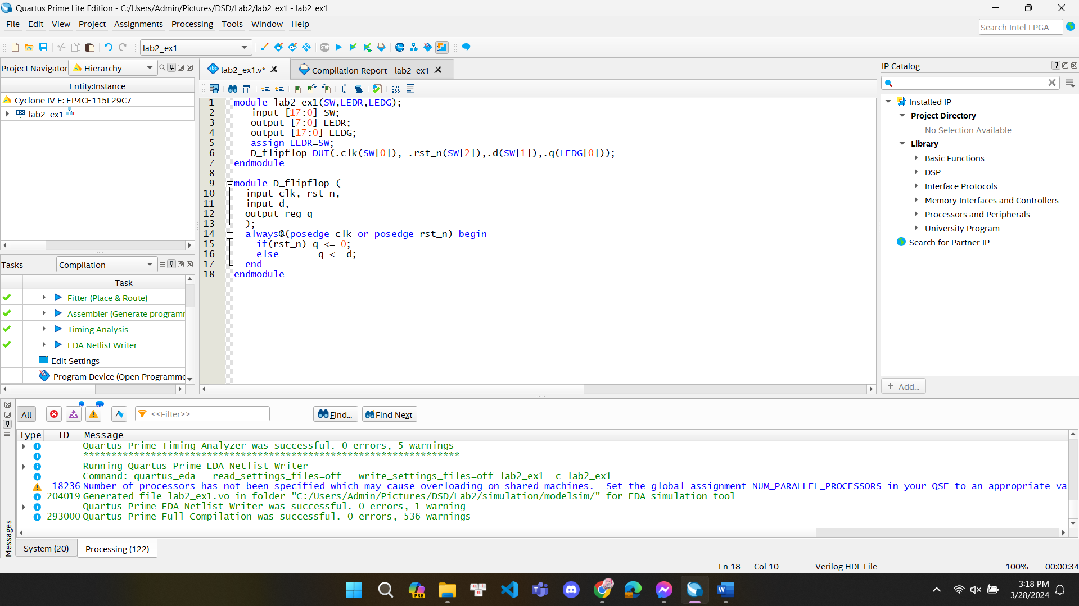

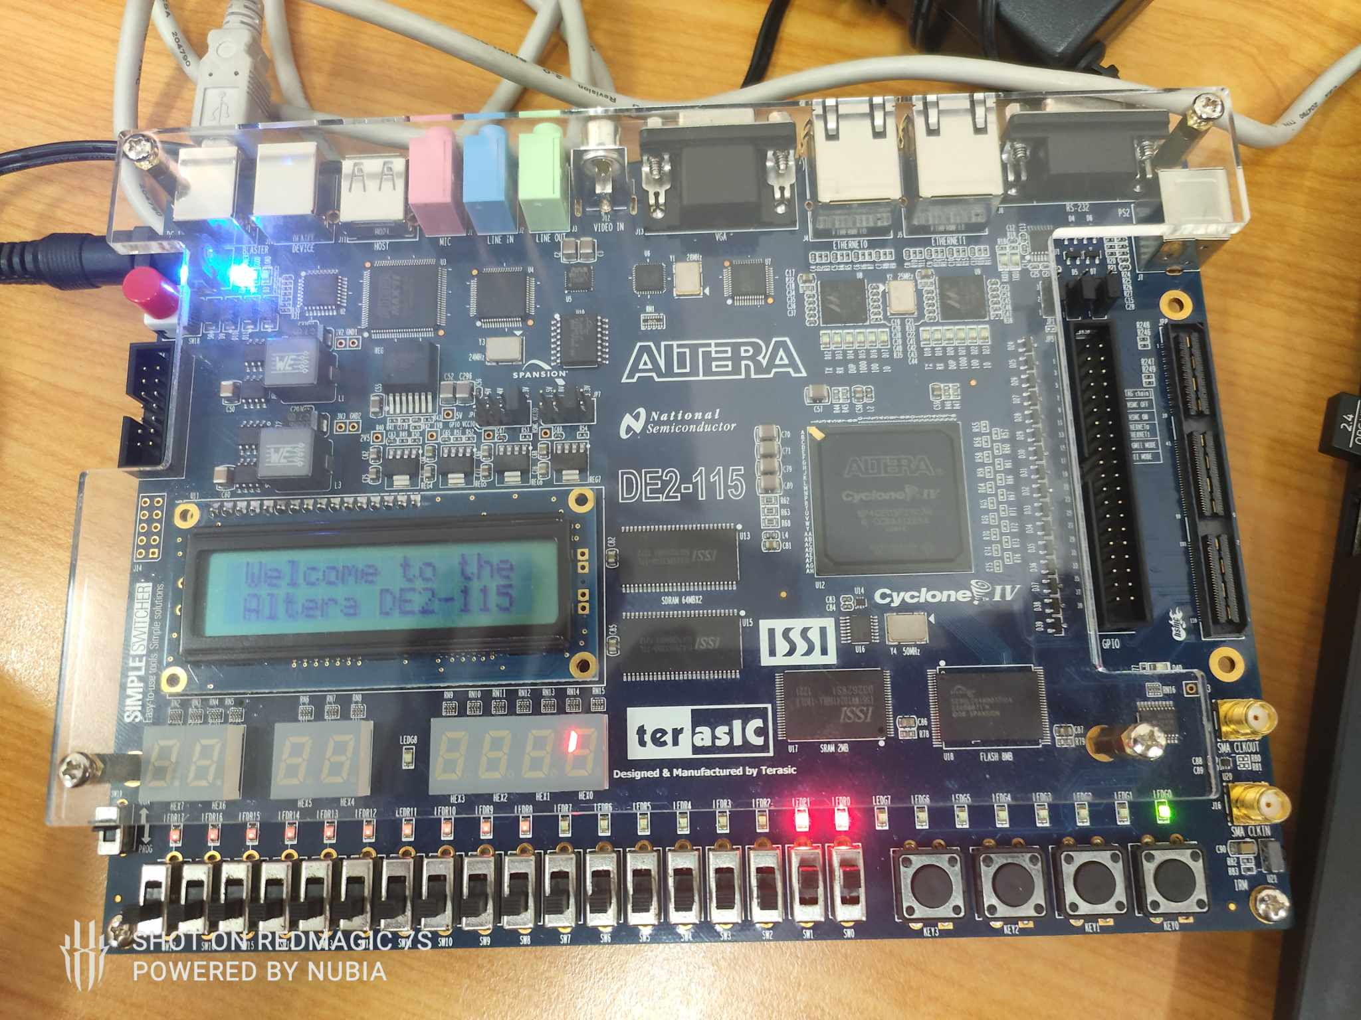

**2. DFF with Asynchronous Reset**

module LAB21(SW,LEDR,LEDG);

input [17:0] SW;

output [7:0] LEDR;

output [17:0] LEDG;

assign LEDR=SW;

D_flipflop DUT(.clk(SW[0]), .rst_n(SW[2]),.d(SW[1]),.q(LEDG[0]));

endmodule

module D_flipflop (

input clk, rst_n,

input d,

output reg q

);

always@(posedge clk) begin

if(rst_n) q <= 0;

else q <= d;

end

endmodule

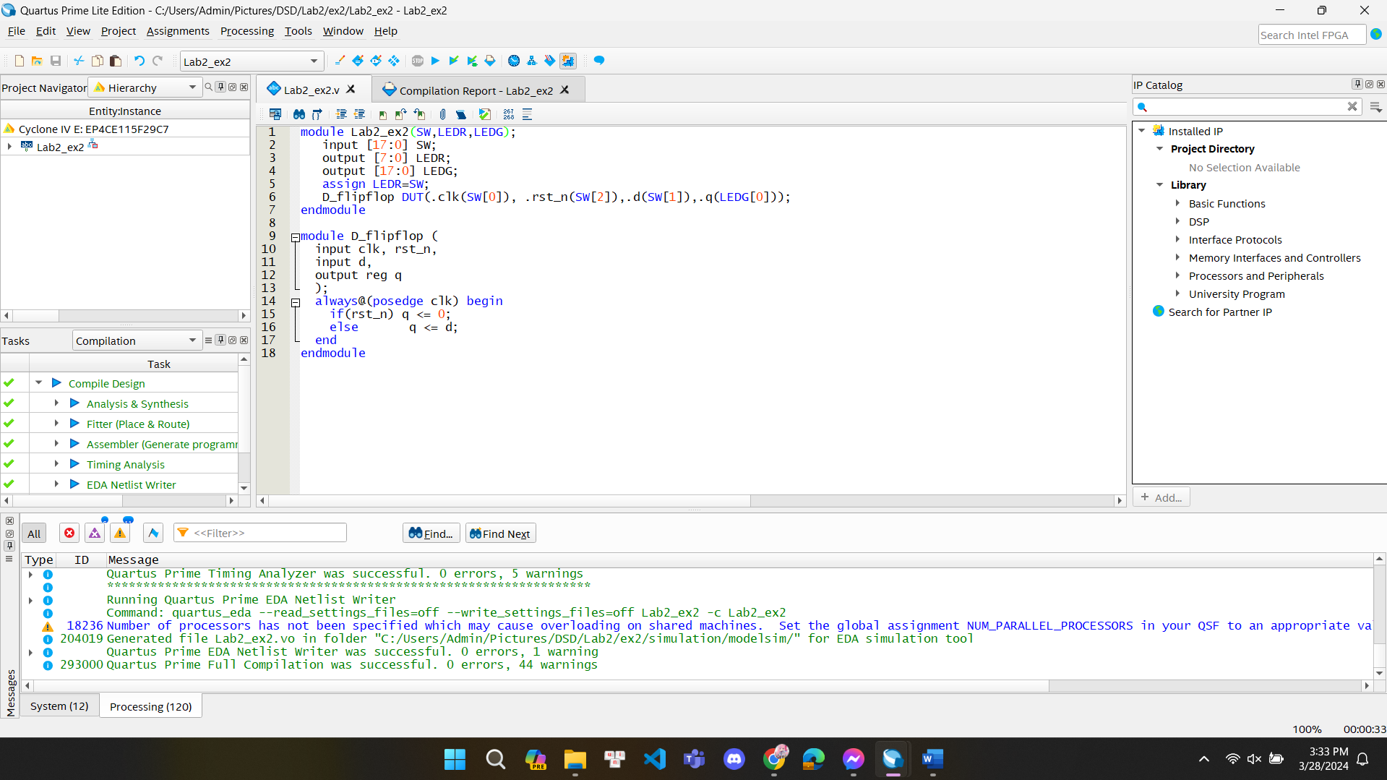

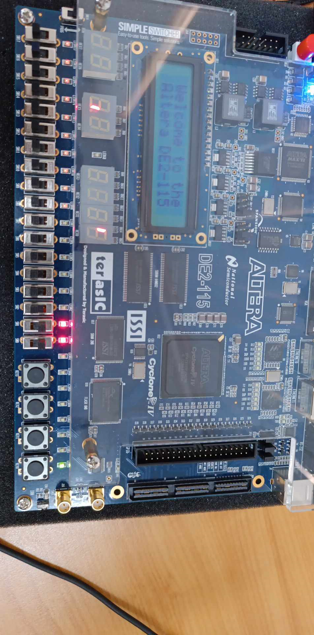

**3. SR Flip Flop**

module Lab2_ex3(SW,LEDG,LEDR);

input[17:0] SW;

output[7:0] LEDG;

output[17:0] LEDR;

assign LEDR=SW;

SR_flipflop DUT(.clk(SW[2]),.s(SW[1]),.r(SW[0]),.q(LEDG[0]),.q_bar(LEDG[1]));

endmodule

module SR_flipflop (

input clk, rst_n,

input s,r,

output reg q,

output q_bar

);

// always@(posedge clk or negedge rst_n) // for asynchronous reset

always@(posedge clk) begin // for synchronous reset

if(rst_n) q <= 0;

else begin

case({s,r})

2'b00: q <= q; // No change

2'b01: q <= 1'b0; // reset

2'b10: q <= 1'b1; // set

2'b11: q <= 1'bx; // Invalid inputs

endcase

end

end

assign q_bar = ~q;

endmodule

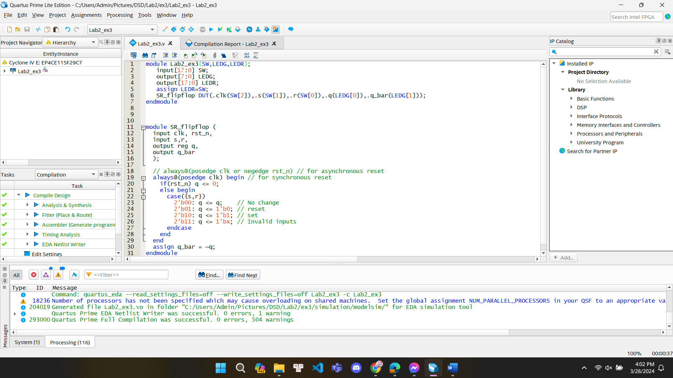

**4 JK Flipflop**

module Lab2_ex4(SW,LEDR,LEDG);

input [17:0] SW;

output [7:0] LEDR;

output [17:0] LEDG;

assign LEDR=SW;

JK_flipflop DUT(.clk(SW[2]), .j(SW[1]),.k(SW[0]),.q(LEDG[0]),.q_bar(LEDG[1]));

endmodule

module JK_flipflop (

input clk, rst_n,

input j,k,

output reg q,

output q_bar

);

always@(posedge clk) begin

if(rst_n) q <= 0;

else begin

case({j,k})

2'b00: q <= q;

2'b01: q <= 1'b0;

2'b10: q <= 1'b1;

2'b11: q <= ~q;

endcase

end

end

assign q_bar = ~q;

endmodule

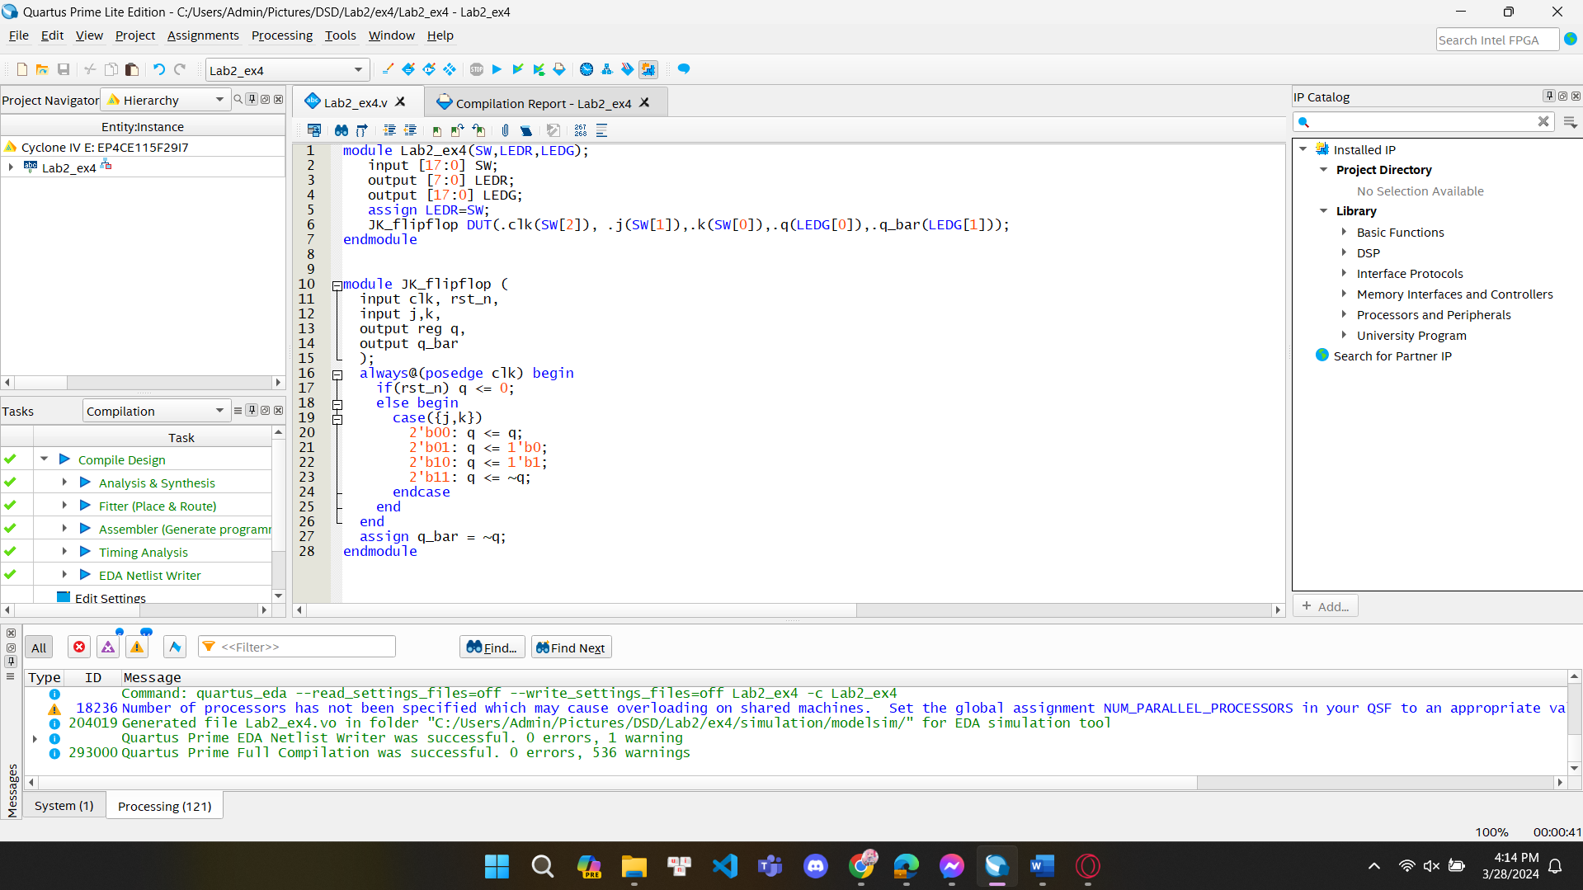

5. T FF  
module Lab2_ex5(SW,LEDR,LEDG);

input [17:0] SW;

output [7:0] LEDR;

output [17:0] LEDG;

assign LEDR=SW;

T_flipflop DUT(.clk(SW[2]), .t(SW[0]),.q(LEDG[0]),.q_bar(LEDG[1]));

endmodule

module T_flipflop (

input clk, rst_n,

input t,

output reg q,

output q_bar

);

// always@(posedge clk or negedge rst_n) // for asynchronous reset

always@(posedge clk) begin // for synchronous reset

if(rst_n) q <= 0;

else begin

q <= (t?~q:q);

end

end

assign q_bar = ~q;

endmodule  
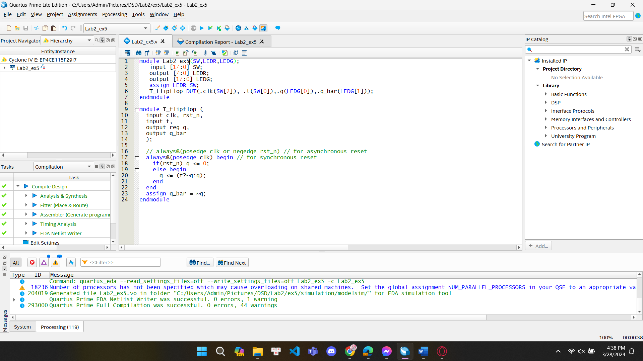

10 ) ASynchronous **Counter 4-bit**

module Lab2_task10(SW,LEDR,LEDG,KEY);

input [17:0] SW;

input [3:0] KEY;

output [17:0] LEDR;

output [7:0] LEDG;

assign LEDR=SW;

synchronous_counter DUT(.clk(KEY[0]),.rst_n(SW[1]),.up_down(SW[0]),.cnt(LEDG[3:0]));

endmodule

module synchronous_counter(clk,rst_n,up_down,cnt);

input clk, rst_n;

input up_down;

output reg [3:0] cnt;

always@(negedge clk) begin

if(!rst_n) begin

cnt <= 4'h0;

end

else begin

if(up_down) cnt <= cnt + 1'b1;

else cnt <= cnt - 1'b1;

end

end

endmodule

**11) count-8bit**

module Lab2_task10(SW,LEDR,LEDG,KEY);

input [17:0] SW;

input [3:0] KEY;

output [17:0] LEDR;

output [7:0] LEDG;

assign LEDR=SW;

synchronous_counter DUT (.clk(KEY[0]),.rst_n(SW[1]),.up_down(SW[0]),.cnt(LEDG[7:0]));

defparam DUT.N=8;

endmodule

module synchronous_counter (clk,rst_n,up_down,cnt);

parameter N=4;

input clk, rst_n;

input up_down;

output reg [N-1:0] cnt;

always@(negedge clk or negedge rst_n) begin

if(!rst_n) begin

cnt <={N{1'b0}};

end

else begin

if(up_down) cnt <= cnt + 1'b1;

else cnt <= cnt - 1'b1;

end

end

endmodule

**9) Shift left right N-bit**module Lab2_ex9(SW,LEDR,LEDG,KEY);

input [17:0] SW;

output [17:0] LEDR;

output [7:0] LEDG;

input [3:0] KEY;

assign LEDR=SW;

Universal_shift_register DUT(.shift_control(SW[1]),.clk(KEY[0]), .rst(SW[2]),.d_in(SW[0]),.d_out(LEDG[7:0]));

defparam DUT.N=8;

endmodule

module Universal_shift_register(clk,rst,shift_control,d_in,d_out);

parameter N=7;

input clk; // clock input

input rst; // reset input

input shift_control;

input d_in; // data input

output reg [N-1:0] d_out; // data output

always @(posedge clk or posedge rst) begin

if (rst) begin

d_out <= {N['b0]};

end

else

begin

if(shift_control) begin

d_out<={d_out[N-1:0],d_in}; // shift left

end

else begin

d_out<={d_in,d_out[N-1:1]}; // shift right

end

end

end

//this is a right shift condition , it is showing that in d_out the user given d_in will be msb and rest 3 bit of existing d_out will be at end means it is shifting right side

//For left shift condition we can use as: d_out<={d_out[3:1], din};

endmodule